1. Design, development and validation of an affordable, portable neonatal hearing screening system combining cortical and brainstem responses (Doctoral Research Project, One Manuscript accepted, One Patent Granted)

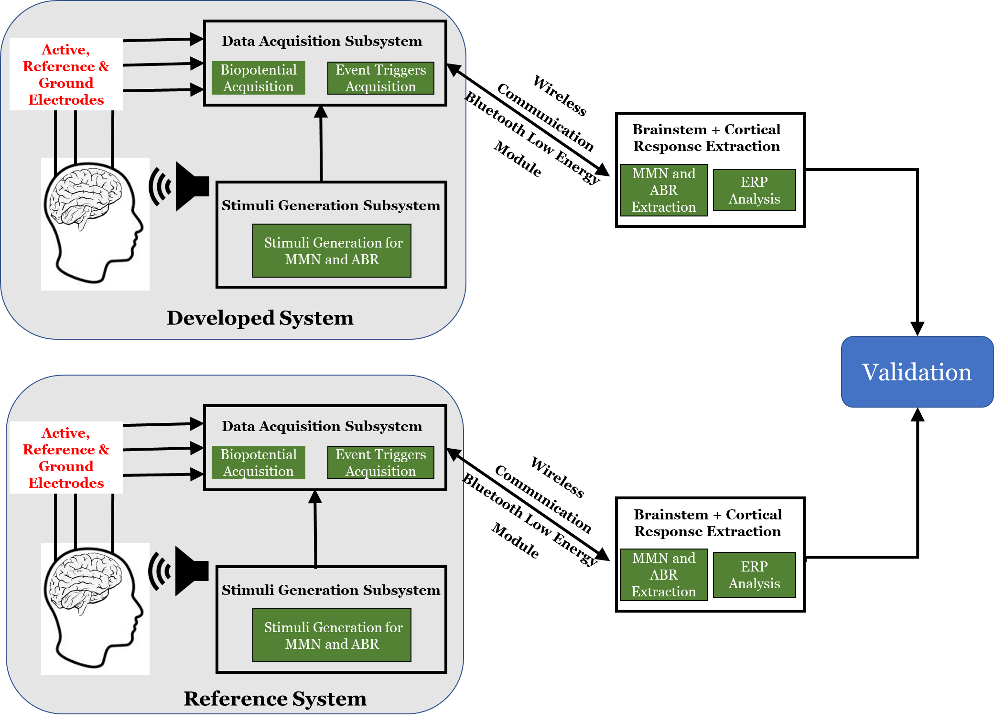

Figure 1 Simplified Experimental Flow of the Auditory Brainstem Response (ABR) and Mismatch Negativity (MMN) Extraction.

1. Design and validate an algorithm to detect and classify epileptic seizures by quantifying Interictal Epileptiform Discharges (IED) from human EEG (Ph.D. Project, One Manuscript accepted, one patent Granted).

Figure 2 Simplified Illustration of the Developed Approach for Automated Interictal Epileptiform Discharges (IED) Pattern Extraction based Epileptic Seizure Detection and Classification.

1. Design, development, and validation of a wearable headband for single event extraction for attention and working memory assessment using P300 Event-Related Potentials (Presented at BIOCAS 2022, Taipei, Taiwan).